**QUIZ WITH DICTIONARY**

OUTPUT WHEN THE USER ENTERS “yes”

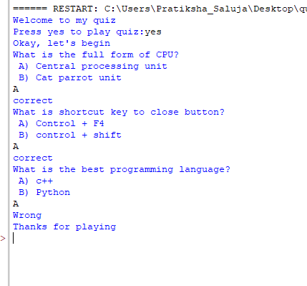

OUTPUT WHEN THE USER ENTERS “no”

